Sample of Questionable Journal Solicitation
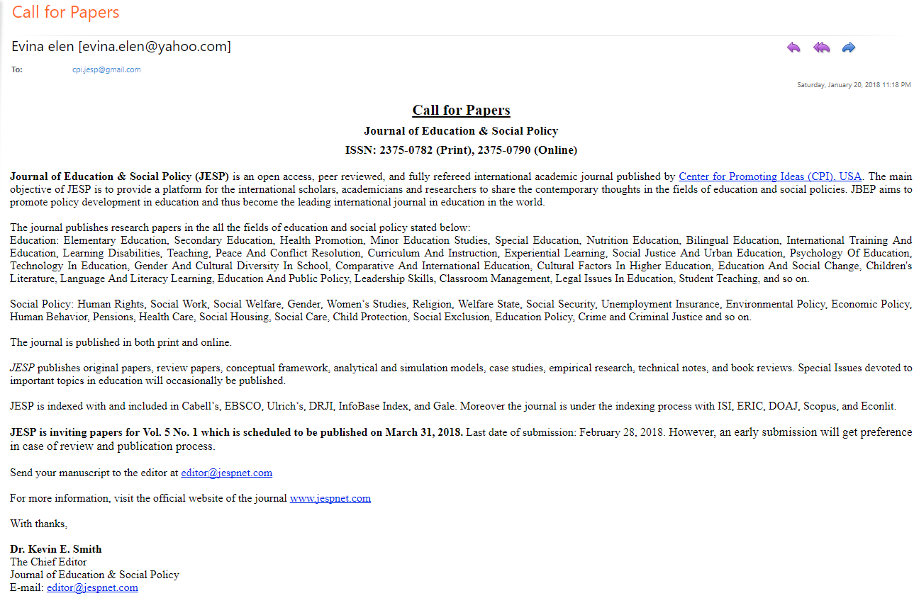
Who | The email appears to be from Evina elen@yahoo.com and addressed to cpiesp@gmail.com, but the signature on the letter is Dr. Kevin E. Smith “The Chief Editor” whose email address is editor@jespnet.com. However, according to the website, the Director (USA) is Dr. John Simth Jr. and his email is johnsmith@cipnet.info. Dr. Kevin E. Smith is a dentist who has his office on the upper westside of NYC about a mile from the fictitious address provided for Center for Promoting Ideas (CPI). The other director listed is for someone in Bangladesh.
Where | The address given is 432 Claremont Avenue, NY, NY 10027. Claremont Avenue is a short avenue on the upper westside of NYC near Barnard College and Columbia University. But there is no 432 Claremont. The avenue ends at 200 Claremont. It is clearly a residential neighborhood. See photo 1 below.
Review Board | “The journals are published from USA under the direct supervisions of renowned academicians of the world. The quick review process, rich editorial boards and quality publications have already made these journals unique.”  “The editorial board is recruiting editors for the journals. Please note that it is a voluntary activity and hence no financial remuneration will be given to the editors. The language of the work is English.” The medium of the work is internet.  Editor's name and affiliation will be listed in the printed journal and on the journal's webpage.  Two individuals from US institutions are listed as serving on a review board for one of the journals: Peter M. Miller and Anne Cross. When asked whether they were affiliated with the journal, Dr. Miller responded, “I’ve never heard of that journal!”
Recruitment of Editors | No vigorous screening of potential editors; minimal information is requested. No CV or academic credentials are requested. See complete application form –photo 2 below.  “If you are interested to be an editor, fill up the prescribed application form and send it to the director at director@cpinet.info.”  “CPI is inviting self-enthusiastic and experienced faculty and researchers worldwide to be the part of its Journals’ editorial teams. Since CPI follows double blind peer review policy, it welcomes those faculty and researchers as the editors who have tolerance and sufficient time to edit/review a research paper rigorously. Please note that it is a voluntary activity and no financial remuneration will be given to the editor. If you think that you are the right person that CPI is looking for, please download the application form for editor and send the completed form to director@cpinet.info”
Non-Standard English Language | There are numerable instances of English language errors throughout the call for papers and the website. See material in quotations in this review document. A few examples are listed here:  “If you have any query, please don’t hesitate to contact with us.”  “self-enthusiastic” “fill up the prescribed application form”  “interested incumbents can apply”
Content | Content too diverse for one journal and group of editors. 27 education topics + “and so on” as well as 20 topics in social policy + “and so on.” Together, the and so ons and the array of material solicited make the journal a catchall.
Affiliation | The journal is part of the Center for Promoting Ideas which does not have an actual physical location or clear ownership. Following a link from the CPI website for one of its listed journals, brings you to another entity, the Mediterranean Center of Social and Educational Research (MCSER), with an address given in Rome, Italy. MSCER is also listed as the publisher of the journal.
Timeline | Last date of submission – Feb. 28, 2018 for publication Mar. 31, 2018. “However, an early submission will get preference in case of review and publication process.”
License to Publish | CPI’s statement regarding “licence to publish” or copyright transfer:  “After the acceptance of your paper please download and send a scanned copy of the License to Publish. By signing the Licence to publish and sending it to MCSER, the author grants the publisher a sole licence for the copyright related acts which have the economic and commercial objective with respect to the article.”
CPI’s Mission | “To create a platform where the researchers and academicians will explore themselves in creating and promoting the world’s new ideas.”
CPI’s Values | Six words (commitment, total quality, innovation (sic), teamwork, timelines and flexibility) are listed on the website along with stock photos. The photo associated with flexibility is a rainbow Slinky® toy. See photo 3 below.
Careers at CPI | The website’s information about careers states:  “At present there is no vacant full time position in CPA. However, interested incumbents can apply for part time positions. Interested incumbents are asked to send their CV along with two copies colors photograph (Passport size) to director at johnsmith@cipnet.info.”
Indexed at DRJI | The website links to http://olddrji.lbp.world/IndexedJournals.aspx . A non-alphabetized list of journals is presented, as well as many partial listings. Each includes a thumbnail of the index certificate. Photos 4, 5, and 6, show screen prints of a page from the index as well as index certificates. The individual listings reviewed show no publishers, and sometimes, no journal name only an ISSN. Photo 6 is a screen shot from DRJI.
DRJI Value | According to DRJI’s website at:  “Now, DRJI launches its new concept of ranking journals known as ‘DRJI Value.’ Its just ranking of journals based on several article publishing techniques which is helpful for improvisation of journals and also article publishing quality and technique. Its just the value indicating journals presence in publication world. IT IS NOT IMPACT FACTOR. It is the value within DRJI database.”
1  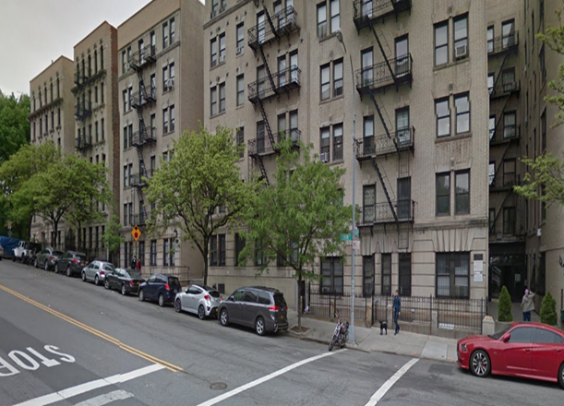 |  | 2  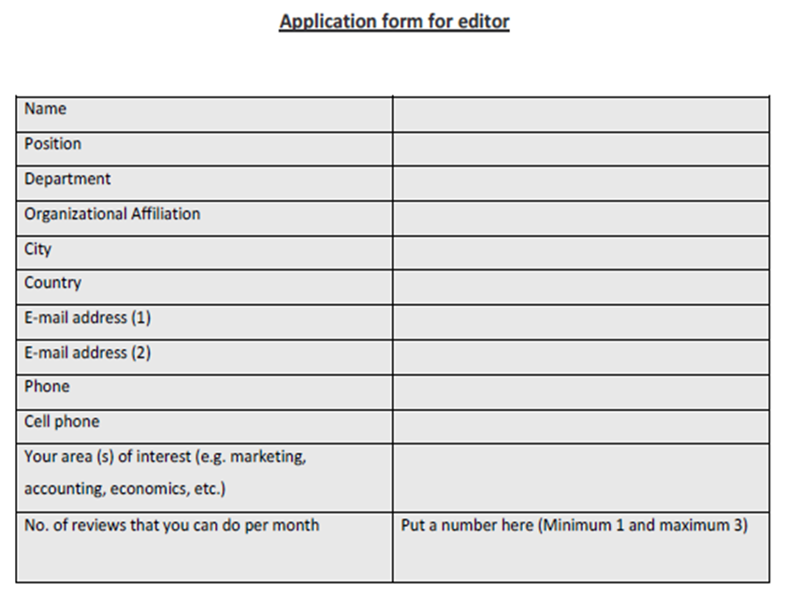
3  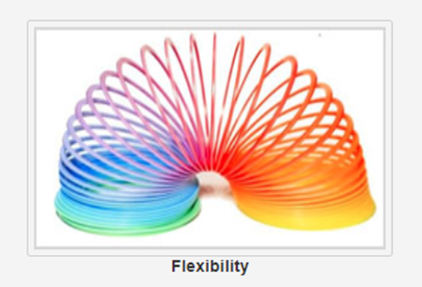 |  | 4  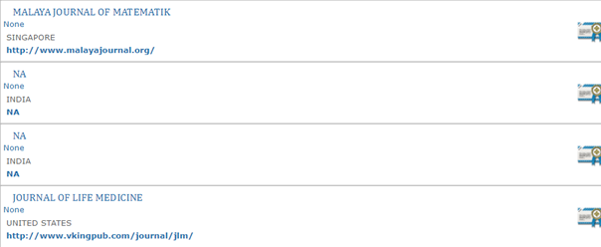

5
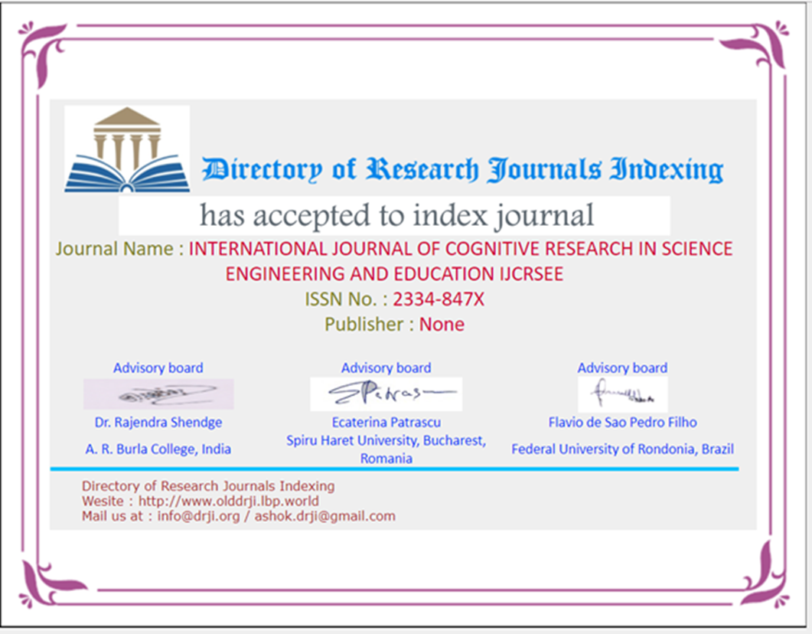
6
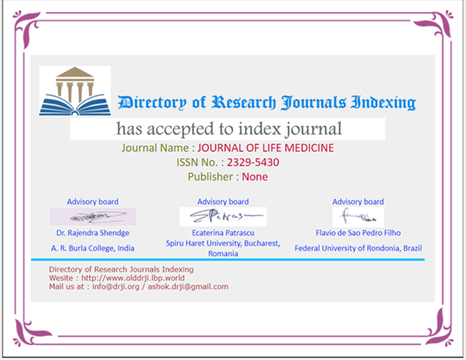
7
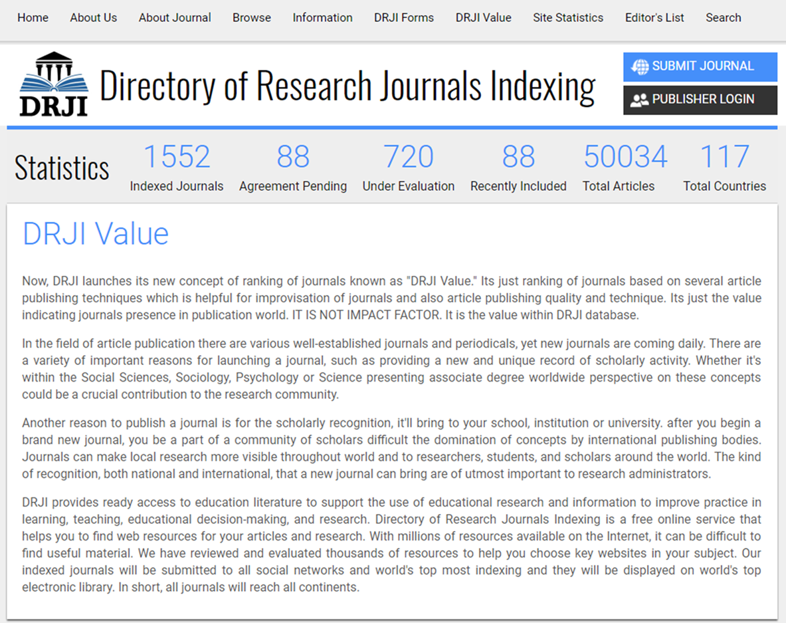

Journals “Run” by the Center for Promoting Ideas
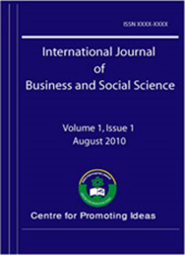 | 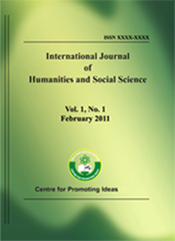 | 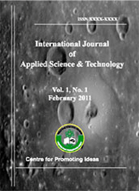
International Journal of Business and Social Science  ISSN: 2219-1933 (Print), 2219-6021 (Online) Subjects: Business, Social Science Editor's E-mail: editor@ijbssnet.com Monthly | International Journal of Humanities and Social Science  ISSN: 2220-8488 (Print), 2221-0989 (Online) Subjects: Humanities, Social Science Editor's E-mail: editor@ijhssnet.com Monthly | International Journal of Applied Science and Technology  ISSN: 2221-0997 (Print), 2221-1004 (Online) Subjects: Applied Science, Technology Editor's E-mail: editor@ijastnet.com Bi-monthly
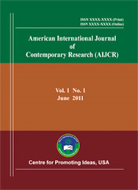 | 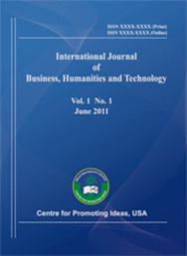 | 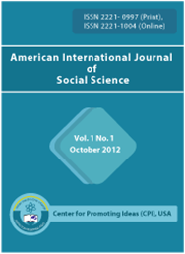
American International Journal of Contemporary Research  ISSN: 2162-139X (Print), ISSN 2162-142X (Online) Subjects: Contemporary Research Editor's E-mail: editor@aijcrnet.com Bi-monthly | International Journal of Business, Humanities and Technology  ISSN: 2162-1357(Print), ISSN 2162-1381(Online) Subjects: Business, Humanities, Technology  Editor's E-mail: editor@ijbhtnet.com  Bi-monthly | American International Journal of Social Science  ISSN: 2325-4149(Print), ISSN 2325-4165(Online) Subjects: Social Science Editor's E-mail: editor@aijssnet.com Bi-monthly
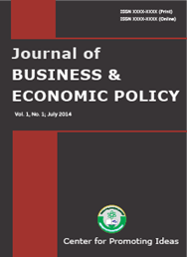 | 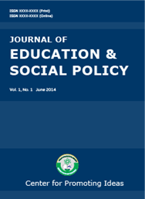 | 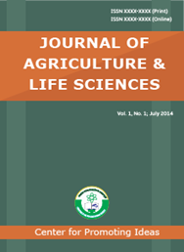
Journal of Business & Economic Policy  ISSN: 2375-0766 (Print), 2375-0774 (Online) Subjects: Business, Economic Policy Editor's E-mail: editor@jbepnet.com Quarterly | Journal of Education & Social Policy  ISSN: 2375-0782 (Print) 2375-0790 (Online) Subjects: Education, Social Policy Editor's E-mail: editor@jespnet.com Quarterly | Journal of Agriculture & Life Sciences  ISSN: 2375-4214 (Print), 2375-4222 (Online) Subjects: Agriculture, Life Sciences Editor's E-mail: editor@jalsnet.com Semi-annually
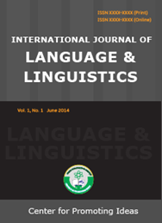
International Journal of Language & Linguistics ISSN: 2374-8850 (Print), 2374-8869 (Online) Subj.Language, Linguistics Editor's E-mail: editor@ijllnet.com Quarterly

