Never Going Back: Lessons to Carry Forward in Online Instruction

Howard Pitler, Emporia State University
Howard Pitler is an associate professor in the Department of School Leadership/Middle & Secondary Teacher Education at Emporia State University, in Emporia, KS. Dr. Pitler teaches graduate courses in educational technology and educational administration, as well as overseeing graduate practicum experiences. He can be reached at: hpitler@emporia.edu.

Amanda Lickteig, Emporia State University
Amanda Lickteig is an associate professor in the Department of School Leadership/Middle & Secondary Teacher Education at Emporia State University, in Emporia, KS. Dr. Lickteig serves as Director of Secondary Education and teaches courses in pedagogy, educational technology, and literacy. She can be reached at: alicktei@emporia.edu.

Seth Lickteig, Emporia State University
Seth is an assistant professor in the Department of Elementary Education/Early Childhood/Special Education at Emporia State University, in Emporia, KS. Dr. Lickteig teaches undergraduate and graduate courses in elementary social studies methods and instructional technology. He can be reached at: slickte1@emporia.edu.

Introduction

With the sudden arrival of the coronavirus disease 2019 (COVID-19) pandemic in the United States in early 2020, learning at all levels immediately shifted to online platforms. This left many educators scrambling to piece together digital learning packages for their students. Even for those with prior knowledge of online teaching practices and tools, there was still the Herculean task of modifying content intended for in-person settings to digital delivery. During this period of emergency remote teaching, the primary objective was simply to “provide temporary access to instruction and instructional supports” (Hodges et al., 2020, p. 6). However, the need for social interaction and support from a community of learners quickly became evident.

Fortunately, past experiences gained from nearly two decades of fully online learning in our Curriculum & Instruction and Educational Administration programs had equipped faculty to encourage and assist their current graduate students—many of whom were now suddenly teaching virtually themselves, while simultaneously supervising their own children’s emergency remote learning. Due to strong Communities of Practice (CoPs), graduate faculty were able help support their adult learners, in part, by relying on the relationships and positive class cultures that had been previously established and nurtured. Therefore, this paper serves to illuminate how Communities of Practice can be established in online learning communities by featuring examples of how the authors encouraged the processes of participation and reification—using appropriate online tools and effective instruction—while fostering a sense of belonging among students.

Review of the Literature

Research has long demonstrated that students thrive best in an online learning community when basic tenants are followed, including peer community, module supports, studying while balancing life commitments, confidence, and approach to learning (Farrell & Brunton, 2020; Kahn, Egbue, Palkie, & Madden, 2017; Dixson, 2010). Albert Bandura emphasized the importance of observing, modeling, and imitating the behaviors, attitudes, and emotional reactions of others in his seminal work on social learning theory (Bandura, 1977). Wenger (1998) then expanded this thinking in his conceptual framework for Communities of Practice (CoP). Most recently, Wenger, Trayner, and de Laat (2011) defined a CoP as a “learning partnership among people who find it useful to learn from and with each other about a particular domain. They use each other’s experience of practice as a learning resource” (p. 9). Wenger’s CoP framework is comprised of four components: practice, community, meaning, and identity (see Fig.1).

Figure 1
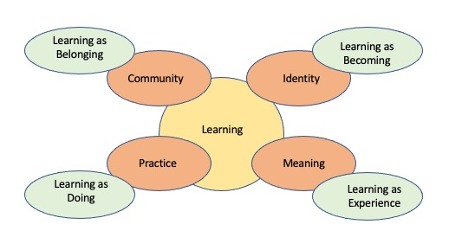
Communities of Practice Framework
Social learning provides the platform for the student to engage with professionals in the field, developing a sense of belonging within a CoP.
This framework has continued to develop in complexity and focus. Two processes are needed to maximize individual engagement in a CoP—participation and reification. Participation involves acting and interacting. Reification involves producing artifacts to make meaning of learning (Wenger, 1998). These processes are inherent in a typical in-person classroom. Students work together to learn and produce artifacts of learning. However, as schools were forced to move to online learning because of COVID-19, it became clear to many educators building CoP in digital environments was arduous because of the lack of physical proximity to one another.
To address this challenge, educators developed new strategies to increase student engagement. Ella Kahu (2013) expanded on Wenger’s work with the development of a holistic framework that depicts student engagement on a broader stage. Kahu’s framework focuses on sociocultural influences, with student engagement at the center and flanked by structural and psychosocial influences as well as proximal and distal consequences (see Fig. 2 below).

Figure 2
Conceptual framework of engagement, antecedents, and consequences
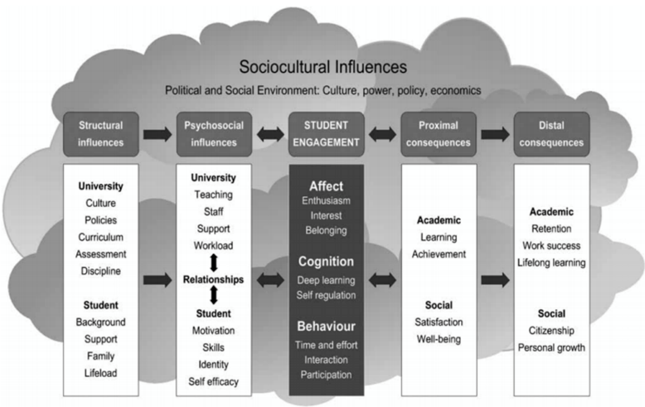

Kahu found that student engagement was influenced by four individual pathways: wellbeing, emotion, self-efficacy, and belonging.
Multiple student, institutional and contextual factors interacted to negatively or positively influence the pathways, for instance increasing or decreasing a student’s wellbeing, depending on the particular context and student. Similarly, the pathways positively or negatively influenced the students’ emotional, cognitive, and behavioral engagement with their study. For example, high self-efficacy or strong belonging could increase engagement, while negative experiences such as stress or anxiety often reduced engagement. (Kahu, 2013, p. 661)
Student engagement in online settings can be challenging for instructors familiar with traditional face-to-face settings. Identifying instructional processes and practices that promote these pathways improve student learning and overall satisfaction with the course.

The Impact of COVID on Instruction

At the start of the COVID-19 pandemic in the United States, the sudden and unexpected shift to online learning in schools at all levels caused schools of education to engage in “stop-gap” measures as they developed content in haste to allow students to continue their educational pathways. The impact on the sociocultural context of learning became more evident to university teaching staff as they moved through the pandemic. University faculty and graduate students alike found themselves isolated and working from home. Health concerns caused universities and school districts to change structural factors in real time, with little or no advance warning to instructors or their students. Educators, with limited experience in digital instruction, were told to move their courses online. Graduate students in education programs were doubly impacted. Not only were they now faced with university classes that were delivered virtually, but they were also responsible for migrating their own classrooms to online settings. These multiple factors negatively impacted student engagement at all levels. The only social interaction between a teacher and students was the internet and the eye of a web camera, thus hindering the formation of a strong CoP. It is important to recognize highly effective face-to-face courses will not automatically translate into effective online courses. Delahunty, Verenikina, & Jones, (2014) found that online learners, more than face-to-face learners, need multiple, deliberately orchestrated opportunities to engage with others in order to compensate for the lack of a physical presence—so that expression, development, tolerance, and recognition of their diverse identities can be maintained. Therefore, designing effective online instruction and then delivering it must begin from the ground up. As educators new to online teaching quickly learned, for remote learning to be effective, it requires a foundation of three critical and complementary components: effective teachers, suitable technology, and engaged learners (Najar-Muñoz, A., Gilberto, A., Hasan, A., Cobo, C. Pedro Azevedo, J., & Akmal, M., 2021).

Our Approach

The graduate programs in Curriculum & Instruction and Educational Administration at our small Midwestern university have been fully online for nearly two decades. While course delivery had naturally evolved during that time, past experiences allowed faculty to maneuver the pandemic and online learning seamlessly. All the courses offered by the university’s Department of Middle and Secondary School Leadership Department were already delivered virtually and asynchronously. Class sizes are often large, between 75-120 students in a seven-week course. Instructors had been using a blend of instructional videos, online assignments, and discussions to build effective CoPs in an online environment. Still, the pandemic had an immediate impact on classes. It became clear that the structural and psychosocial influences graduate students were dealing with were substantially different than pre-pandemic experiences. Veteran teachers who had previously had a strong sense of self-efficacy were suddenly questioning their very ability to teach. These graduate students were now teaching virtually, while their own children were simultaneously learning from home—often in the same room. Emotions were stretched to their limits. The university professors regularly engaged in conversations about how to balance course rigor and grace. Outreach with students increased by offering frequent Zoom office hours, direct emails, extended deadlines, and check-in phone calls.

Faculty also continued to refine teaching strategies. Student feedback gathered through end-of-course IDEA evaluations (Instructional Development and Effectiveness Assessment) indicated that students found traditional discussion board assignments repetitious and boring. Students indicated that they were tired of the “post by Wednesday and reply to at least two other students by Sunday” routine. Faculty also noted peer-to-peer interaction and communication (key elements in building a strong CoP) needed attention. Rather than everyone adopting a lockstep discussion board strategy, instructors approached the issue individually. For example, the building level practicum course moved away from typical discussion boards to a virtual table group approach. Students were randomly assigned to a group of four and worked with that same group throughout the course, providing peer feedback and developing a sense of belonging. One assignment within their peer table group was to write a 30-second video elevator speech the student might use when applying for a principalship. They then “workshopped” the video in their virtual table group and received critique and feedback, incorporated that feedback, and submitted the final video to the instructor.

Regularly throughout the weekly modules, instructors in the curriculum and instruction program would introduce a course topic—often through a mix of readings, supplemental media, and short instructional videos—and then require students to implement that concept for their weekly assignment, thus modeling application of the course concept being discussed and providing variety in the learning tasks. For example, one module in a brain-based learning class addressing creativity and the brain examines the impact of the arts and movement on student learning and behavior. To summarize the key themes of the module, students are asked to incorporate these concepts by following one of three assignment options: composing and performing a poem or song, developing a set of sketch notes, or recording themselves acting out key concepts and essential vocabulary. However, additional examples include developing interactive reviews when the module features information on using quiz games to introduce novelty into a lesson, creating digital concept maps when the content of that week highlights graphic organizers, and even outlining an action research proposal in a module advocating for candidates to gather data and determine the effectiveness of the strategies presented (Sousa, 2017). In other classes, students demonstrated understanding of course concepts by completing conference proposals and developing presentations and poster sessions for final projects.

At the core of these new approaches, was the foundation of establishing and maintaining a positive online class culture. Although endeavors in building classroom community are often skipped at the graduate level, research has long demonstrated the “integral role in the advancement of student learning” that a strong sense of belonging can have (Summers & Svinicki, 2007, p. 57). Faculty found instructor-facilitated practices such as structured class introductions, intentionally connecting students with similar positions or aspirations, and providing specific and personalized assignment feedback ensured that students felt comfortable in the learning environment. These practices, combined with sharing students’ products of learning to non-traditional discussion boards as a public repository for class colleagues to see (Lickteig, 2022), allowed for a robust CoP where students truly felt comfortable using “each other’s experience of practice” to “learn from and with each other” (Wenger, Trayner, & de Laat, 2011, p. 9).

Conclusion

Much like the K-12 teachers who were surveyed about their experiences during the first year of the pandemic (Powell, 2021), we ultimately hope some instructional practices developed and honed during the pandemic are here to stay. Previously, our students demonstrated a reluctance to engage with peers and faculty in online settings. These courses were often described as independent studies by students with each student progressing at their own pace. By incorporating CoPs into the framework of our course delivery, students formed relationships with all participants through purposeful, iterative interaction and conversation. One characteristic of face-to-face CoPs is a vibrant exchange of ideas and feedback. Online courses lack such exchanges, as students never meet one another face-to-face. Student feedback on the courses that employed a virtual table discussions strategy indicated that students felt a greater sense of community when they intentionally worked with the same small group of students and provided each other with direct feedback and encouragement. So, to echo a question posed by graduate teaching fellow Mohammad Meerzaei, how did this period of adaptive teaching make us better educators (Byer, 2021) and what practices will we be carrying forward? As teacher educators, our collective goal should be to create Communities of Practice that are accessible and meaningful for our students, regardless of course delivery. If teaching and learning returns to the way it was pre-COVID, we will have lost a great opportunity to improve instruction.

References

Bandura, A. (1977). Self-efficacy: Toward a unifying theory of behavioral change. Psychological Review, 84(2), 191-215.
Byer, C. (2021, March 15). New blog series asks faculty to share what practices they will carry forward in post-pandemic teaching. Center for Teaching. https://cft.vanderbilt.edu/2021/03/new-blog-series-asks-faculty-to-share-what-practices-they-will-carry-forward-in-post-pandemic-teaching/
Delahunty, J., Verenikina, I., & Jones, P. (2014). Socio-emotional connections: Identity, belonging and learning in online interactions. A literature review. Technology, Pedagogy and Education, 23(2), 243–265. https://doi.org/10.1080/1475939X.2013.813405.
Dixson, M. D. (2010). Creating effective student engagement in online courses: What do
students find engaging? Journal of the Scholarship of Teaching and Learning, 10(2),
1-13. https://files.eric.ed.gov/fulltext/EJ890707.pdf
Farrell, O. & Brunton, J. (2020). A balancing act: A window into online student engagement
experiences. International Journal of Educational Technology in Higher Education, 17(25). https://doi.org/10.1186/s41239-020-00199-x
Hodges, C., Moore, S., Lockee, B., Trust, T., & Bond, A. (2020). The difference between emergency remote teaching and online learning. Educause Review, 27, 1–12. https://er.educause.edu/articles/2020/3/the-difference-between-emergency-remote-teaching-and-online-learning.
Kahu, E. R. (2013). Framing student engagement in higher education. Studies in Higher Education, 38(5), 758–773. https://doi. org/10.1080/03075079.2011.598505.
Khan, A., Egbue, O., Palkie, B., & Madden, J. (2017). Active learning: Engaging students to
maximize learning in an online course. Electronic Journal of e-Learning, 15(2).
107-115. https://eric.ed.gov/?id=EJ1141876
Lickteig, A. (2022, January 2-6). Ditching discussion boards: Providing voice and choice to students through alternative platforms. [Conference presentation abstract]. Twentieth annual convention of the Hawaii International Conference on Education, Waikoloa Village, HI, United States. http://hiceducation.org/wp-content/uploads/2021/12/22-Final-Program.pdf.
Powell, E. (2021). Three pandemic lessons for teachers to carry forward. ASCD. https://www.ascd.org/blogs/three-pandemic-lessons-to-carry-forward
Sousa, D. A. (2017). How the brain learns. (5th ed.). Thousand Oaks, CA: Corwin.
Summers, J. J. & Svinicki, M. D. (2007). Investigating classroom community in higher education. Learning & Individual Differences, 17, 55-67. doi:10.1016/j.lindif.2007.01.006
Wenger, E. (1998). Communities of practice: Learning, meaning, and identity. New York, NY: Cambridge University Press.
Wenger, E., Trayner, B., & de Laat, M. (2011). Promoting and assessing value creation in communities and networks: A conceptual framework. Heerlen, The Netherlands: Ruud de Moor Centrum, Open University of the Netherlands.
Wenger, E., White, N., & Smith, J. D. (2009). Digital habitats: Stewarding technology for communities. Portland, OR: CPSquare.

Najar-Muñoz, A., Gilberto, A., Hasan, A., Cobo, C. Pedro Azevedo, J., & Akmal, M. (2021). Remote learning during COVID-19: Lessons from today, principles for tomorrow. The World Bank. Retrieved 26 August 2022, from https://documents1.worldbank.org/curated/en/160271637074230077/pdf/Remote-Learning-During-COVID-19-Lessons-from-Today-Principles-for-Tomorrow.pdf

