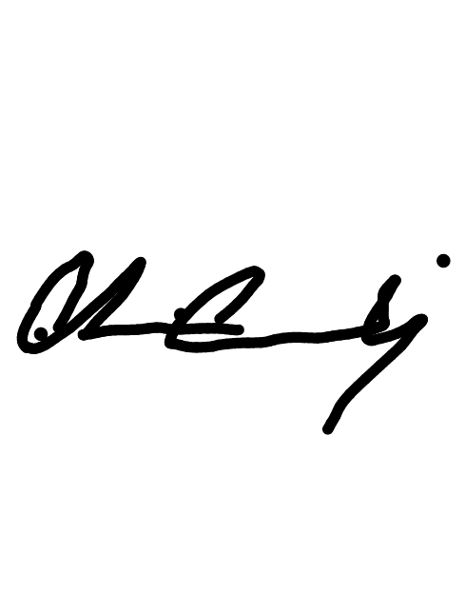
I acknowledge that I have received and understand the APA Format Checklist CC .(initials here)
Reimagining Career Semiotics toward Application Efficiencies and

Programmable Efficacies: A Phenomenological Analysis
David Paul Dean
De Forest University
Title: Centered left to right, double spaced in the upper half of the page
Author’s Name: Your name, double spaced and centered
Institutional Name: School name, double spaced and centered

APA Format Checklist
Items marked with a * will be automatially supplied when an article is published; the author is not required to include these fields in the manuscript.

SAMPLE RESEARCH PAPER: TITLE PAGE FORMAT CHECKLIST
Running head: REIMAGINING CAREER SEMIOTICS
1
Title Page Header: “Running head:” followed by a short title in all capital letters*
Page Number: Page numbers are flush right at the top of the page *


The first line is not indented. Subsequent paragraphs should be indented.
SAMPLE RESEARCH PAPER: ABSTRACT FORMAT CHECKLIST
REIMAGINING CAREER SEMIOTICS
Abstract
2

Career-based disparate pairings interview analysis techniques coupled with descriptive consciences descriptive analysis employing genitive epistemological pairings are integrated with interviews of students successfully seeking career residual rectification of promotable improvements. These are associatively tracked with employable knowledge, skills, aptitudes, abilities, and with multiple psychotechtic intelligences.
Results indicate further research is needed to support advances toward these
Running Header: Short title in all capital letters *
The Abstract: The abstract appears on a separate page.
The word “Abstract” is capitalized, centered and not bolded

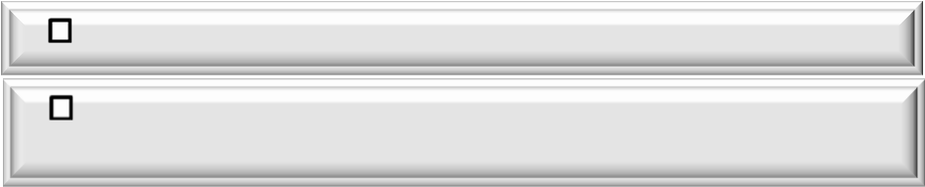SAMPLE RESEARCH PAPER: FIRST PAGE FORMAT CHECKLIST
Reimagining Career Semiotics toward Application Efficiencies and

Programmable Efficacies: A Phenomenological Analysis
(Gaylor, Hughes,
and Carvajal, 2012)
two
Burke, Burden, & Wedes (1997)
Literature Review
ure explorations.
Limitations of the Current Study
je ne sais quoi
(Rossi-Howrey Foundation, 2002
t Sanders et al.
“optimal compiler is as elegant as its o
Paragraphs are indented 5 spaces
post-futurist study
As Ostrowski (2012), acknowledges in her
modeling is highly constrained due to the simulated attitudinal annealing. However work with senior job seekers revealed meta-rhythmic cyclisation closely linked to audited intelligences ). It was not until the Kunnapas Effect was audited tha realized the,
wn ambition” (2004, p. 444). Thus, the
stage was smartly set for fut
observed in their classic study; Riley
As
Experienced career seekers carry the commonly held perceptions of the widely regarded Saussurean tradition of signs and symbols imparting psychotomic cues related to the interview process. Amelioration of application inefficiencies and enhancement of efficacies pertaining to programmable functionalities are central tendencies of desired outcomes of complexity management, ambiguity centering, and values self-confliction
. Traditional research approaches have remained elusive in casting the traditional imaging cycles of patterns. This study employs a bevy of phenomenological tools designed to hone in on these angst inducing extrapolations. This study will explore why dis-associative functioning, with the
onset of string pair career bindings, results in such inconsistent outcomes.
3
REIMAGINING CAREER SEMIOTICS
The Title: The full title is centered and not bolded
Level 2 Headings: Bolded, flush left in upper and lower case

Commonly used foreign words and phrases are not italicized
Paper Format:
Double-space all sections of your paper
Use a 12 point font such as Times New Roman
Have a one inch margin on the right, left, top, and bottom Align the text to the left and leave a “ragged” right margin
Use in-text citations to cite your sources
Spell the numbers 1-9 as words, such as: one, two, and four Anything above 10 is written in numerals, such as: 11, 52, or 125 Numbers starting a sentence are written as words: Two or Twenty

Level 1 Headings: Bolded, centered, in upper and lower case
When the author is a signal phrase, put the date in parentheses

The author may be an organization
If you are quoting, include the page number in the citation

For six or more authors, use the first author's name, followed by “et al.”

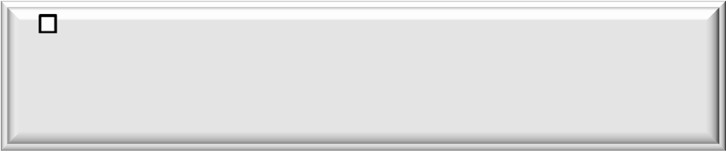SAMPLE RESEARCH PAPER: REFERENCES PAGE FORMAT CHECKLIST
References
Burke, H., Burden, P., & Wedes, L. (1997). Using the Riley Model for fun and profit while amazing your friends. Jondrow Review and Analytical Companion, 3(6), 234-256.
Gaylor, D., Hughes, B., & Carvajal, J. (2012). Programmable functionalities: An outcomes orientation. London, UK: Oxbridge.
Johnson, P., Louderback, J., Tesar, B., Sanders, F. E. M., Lanka, E., Marino, B., & Golamb, L. (2004). The transcendent ease of optimal compiling: Or how I learned to stop worrying about compiling and love it! Meyer State University Journal of Information Antics, 1(1), 1-89.
Ostrowski, M. (2012). La déconstruction. Retrieved from http://onlineEditionsJ-L-Picard.fr Rossi-Howrey Foundation. (2002, August). Meta-rhythmic cyclisation: Implications for
employment (Research Report No. 5). Retrieved from http://www.rossi- howeryfound.org/pubsno5
Tesar, B., & Sanders, F. E. M. (2001). Job seekers reveal their meta-rhythmic cyclisation.

Kidd Society Quarterly, 12(12). Retrieved from http://KiddSocietyQ.org
27
REIMAGINING CAREER SEMIOTICS
List of References begins on a new page at the end of the paper
The word “References” is capitalized and centered, but not bolded
The list is doubled spaced
First line of each citation is flush left. Use the Hanging Indent in MS Word to indent subsequent lines five spaces.
List is arranged alphabetically by the first word of each entry— typically the surname of the lead author or the authoring organization. If there is no author the first word of the title is used (ignoring “A,” “An,” or “The”)
Titles of book and journals are italicized.


Basic Magazine Article Checklist from a Library Database
In-text citation options |  | List of References
 | If the author is part of the narrative:  Carroll (2014) advocated team rebuilding. | Carroll, P. (2014, February 4). Elements of teamwork. Week: The Timely Magazine, 12(12), 4-7. doi.org/10.1037/0002
 |  |  | Author is listed by last name followed by initial(s)
 |  |  | Publication date (year, month, and day) is placed between parentheses, followed by a period
 | Standard in-text citation:  Preparation for separation yielded significant results (Carroll, 2014). |  | Article’s title is in sentence-case, with only the first word in the title and subtitle and proper nouns capitalized.  Article title ends with a period
 |  |  | Magazine title is run in title case, italicized, and ends with a comma
 |  |  | Volume number is also italicized
 | Note: Only the year is used for the date in both cases. |  | Issue number is in parenthesis and followed by a comma after the closing parenthesis
 |  |  | Page numbers are followed by a period.
 |  |  | Provide the DOI (Digital Object Identifier), if available¹
If the DOI is not available, provide the homepage URL of the periodical or publisher. Generally, it is not
necessary to provide the database.

Basic Magazine Article Checklist From Their Website
In-text citation options |  | List of References
 | If the author is part of the narrative:  Wilson (2014) supports visualization of goals. | Wilson, R. (2014, February 3). Why not us? World News Report, 12(12), 1-5. Retrieved from  http://WorldNewsReport.com
 |  |  | Author is listed by last name followed by initial(s)
 |  |  | Publication date (year, month, and day) is placed between parentheses, followed by a period
 | Standard in-text citation:  He taught his mentors (Wilson, 2014). |  | Article’s title is in sentence-case, with only the first word in the title and subtitle and proper nouns capitalized.  Article title ends with a period or punctuation in the original
 |  |  | Periodical title is run in title case, italicized, and ends with a comma
 |  |  | Volume number is also italicized
- N date | ote: Only the year is used for the in both cases. |  | Issue number is in parenthesis and followed by a comma after the closing parenthesis
- N date | ote: Only the year is used for the in both cases. |  | Page numbers are followed by a period
 |  |  | Provide the DOI¹, if available
 |  |  | If the DOI is not available, provide the URL preceded by the phrase “Retrieved from”
 |  |  | Just the URL of the magazine is used, unless the article would be difficult to locate.

1 DOI (Digital Object Identifier) is a unique identifier assigned to individual printed and electronic works.



Basic Journal Article Checklist from Library Database With a DOI
In-text citation options |  | List of References
 | If the author is part of the narrative:  Bird (2013) sees the added dimension as viable. | Bird, N. (2013). Tran’s dimensionality transcending, but descending: A Cartesian argument. E-Journal of the  Otaa-Gyamfi Institute, 23 (2), 50-69. doi: 10.98757505757
 |  |  | Author is listed by last name followed by initial(s)
 |  |  | Publication date (year) is placed between parentheses, followed by a period
 | Standard in-text citation:  Inter- dimensionality is the new normal (Bird, 2013). |  | Article’s title is in sentence-case, with only the first word in the title and subtitle and proper nouns capitalized.  Article title ends with a period or punctuation in the original
 |  |  | Periodical title is run in title case, italicized, and ends with a comma
 |  |  | Volume number is also italicized
 |  |  | If each issue of the journal begins on page 1, provide the issue number
 |  |  | Issue number is in parenthesis and followed by a comma after the closing parenthesis
 |  |  | Page numbers are followed by a period
 |  |  | Provide the DOI¹, if available

Basic Journal Article Checklist from Library Database Without a DOI
In-text citation options |  | List of References
 | If the author is part of the narrative:  Kincaid (2014) initially disregarded the Bell Theorem. | Kincaid, J. (2014). Expanding the Bell Theorem: A new application of the Goldsmith Postulate. Blackwell  Journal of the Arcane Polymorphous Arts, 54, 887-963.
 |  |  | Author is listed by last name followed by initial(s)
 |  |  | Publication date (year) is placed between parentheses, followed by a period
 | Standard in-text citation:  Adding the Goldsmith Postulate yielded results (Kincaid, 2014). |  | Article’s title is in sentence-case, with only the first word in the title and subtitle and proper nouns capitalized.  Article title ends with a period or punctuation in the original
 |  |  | Periodical title is run in title case, italicized, and ends with a comma
 |  |  | Volume number is also italicized
 |  |  | If each issue of the journal begins on page 1, provide the issue number
 |  |  | Issue number is in parenthesis and followed by a comma after the closing parenthesis
 |  |  | Page numbers are followed by a period
 |  |  | Generally, it is not necessary to provide the database.
If no DOI¹ is available and you retrieved it from a journal website, use this format: Retrieved from
http://www.xxxx




 |  |  |  | Electronic Version of a Print Book
In-text citation options |  | List of References
 | If the author is part of the narrative  Bortz (2014) sees students taking the meta-textual horse for the meta-textual drink. | Bortz, S., & Carvajal, J. (2014). Introduction to Meta-textualization [VitalSource version].doi: 10.849hognohu363g
 |  |  | Authors are listed by last name followed by initials
 |  |  | Publication year is placed between parentheses, followed by a period
 |  |  | Book title is in italicized, sentence-case, and ends with a period
 |  |  | In brackets [ ] tell the source of the eBook
 | Standard in-text citation:  This was career-focused mythic- poetical e-discourse at its finest (Bortz, 2014). |  | DOI is provided. If it is not available use the URL
 |  |  | Note: No publication and publisher

 |  |  |  | Book only available in eBook format
In-text citation options |  | List of References
 | If the author is part of the narrative | Caldarello, B. A. (2009). Five stages of seeking. doi:1068oiyti
 | Caldarello (2009) maintained the |  | Authors are listed by last name followed by initials
 | Caldarello (2009) maintained the |  | Publication year is between parentheses, followed by a period
 | archives would prove invaluable |  | Book title is italicized, sentence-case, and ends with a period
 | archives would prove invaluable |  | DOI is provided. If it is not available use the URL
 | Standard in-text citation: |  | Note: No publication and publisher
 | Eminence typically succeeds over pre- eminence (Caldarello, 2009).





Basic Website Checklist
If you cite an entire website, just give the URL
In-text citation options |  | List of References
 | If the author is part of the narrative  GleasnerNet (2013) discussed five objectives. | GleasnerNet. (2013). Retrieved October 10, 2013, from GleasnerNet website: http://www.GleasnerNet.com.
 | Standard in-text citation: The firm promoted itself well (http://www.GleasnerNet.com). |  |  |  | The title for the entire website is provided in lieu of an author
The date the site was last update is provided as it is available. This may or may not include a month or a day. If
there is not a date provided, enter “n.d.” in the parenthesis.
 |  |  |  |  | Include the retrieved from date only if it is likely that content of the database will change
If you cite a page or part of a website use the author date in-text citation
When Quoting |  | Glenn, D. (2014, February 10). Tantric ruminations. Retrieved from http://www.GleasnerNet.com
 | When quoting, use paragraph numbers, if they are available:  Glenn (2014) reported higher than average earnings (para.3). |  |  |  | Author is listed by last name then initials.  The date the site was last update is provided as it is available. This may or may not include a month or a day. If there is not a date provided, enter “n.d.” in the parenthesis.
The webpage’s title is in sentence-case, with only the first word in the title and subtitle and proper nouns
capitalized. The title ends with a period
 | If paragraphs are not numbered, use a heading and the number of the paragraph, even if not-numbered.  (Glenn, 2014, “R&D,” para. 7). |  |  |  | The phrase “Retrieved from” is followed by the URL of the site

Remedies for Missing Elements
Missing Element |  | Remedy
 | Author is missing | Substitute title for author  The week that wasn't. (2014, April 15). Week: The Timely Magazine, 34(32), 5.
 | Date is  missing | Substitute (n.d.) for no date.  Owusu (n.d.) broke new ground with his idea.
 | No place of publication | If you can determine location of the publisher,  insert it in square brackets: [Crystal City, VA].

Levels of Headings—APA uses five level of headings in papers
Heading Level | Format
1 | Centered, Boldface, Uppercase and Lowercase Heading  Begin your text below with an indented paragraph.
2 | Left-aligned, Boldface, Uppercase and Lowercase Heading  Begin your text below with an indented paragraph.
3 | Indented, boldface, lowercase heading with a period.  Begin your text after the period.
4 | Indented, boldface, italicized, lowercase heading with a period.  Begin your text after the period.
5 | Indented, italicized, lowercase heading with a period.  Begin your text after the period.


Type of citation | First citation in text | Subsequent citation in text | Parenthetical format, first citation in text | Parenthetical format, subsequent citations in text
One work by one  author | Hanses (2009) | Hanses (2009) | (Hanses, 2009) | (Hanses, 2009)
One work by two  authors | Franklin and Farber (2005) | Franklin and Farber (2005) | (Franklin & Farber, 2005) | (Franklin & Farber, 2005)
One work by three authors | Gullikson, Hooker, and  Keller-Rabner (2011) | Gullikson et al. (2011) | (Gullikson, Hooker, & Keller-  Rabner, 2011) | (Gullikson et al., (2011)
One work by four authors | Lippman, Berezowski, Riley,  and Sabatini (2012) | Lippman et al. (2012) | (Lippman, Berezowski, Riley, &  Sabatini , 2012) | (Lippman et al., 2012)
One work by five authors | Stephens, Wagoner-Perry, Pasternack, Williams, and  Baldwin (2001) | Stephens et al .(2001) | (Stephens, Wagoner-Perry, Pasternack, Williams, & Baldwin  (2001) | (Stephens et al ., 2001)
One work by six or more  author | Gaylor et al. (2014) | Gaylor et al. (2014) | (Gaylor et al., 2014) | (Gaylor et al., 2014)
Group author (readily identified  through abbreviation) | Institute of Electrical and Electronics Engineers (IEEE,  2000) | IEEE (2000) | (Institute of Electrical and Electronics Engineers [IEEE],  2000) | (IEEE, 2000)
Group author (with imprecise abbreviation) | Mississippi Power (2006) | Mississippi Power (2006) | (Mississippi Power, 2006) | (Mississippi Power, 2006)



NOTE: This is a general guide to APA formatting and style.
For further information please consult:
The APA Style site (http://www.apastyle.org/index.aspx) The APA Publication Manual BF 76.7 .P83 2010

