Table 1. Code Frequency Summary
Interviews | Frequency (N=35)
Interviewee Origin
Non-Local | 18
Local | 9
Local Returnee | 8
Parent Code | Frequency (N=1250)
Behavior
Sub-Codes | 12
Coded Statements | 250
Event
Sub-Codes | 7
Coded Statements | 261
Mental Model
Sub-Codes | 18
Coded Statements | 230
System
Sub-Codes | 11
Coded Statements | 509

Alt text: Table displays identified codes and sub-codes and their frequencies from coded interviews.

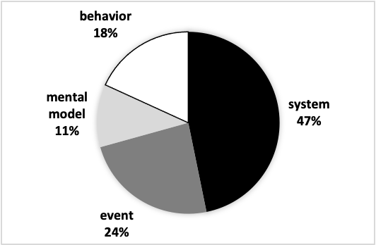
Figure 1. Top Occurring Sub-Codes

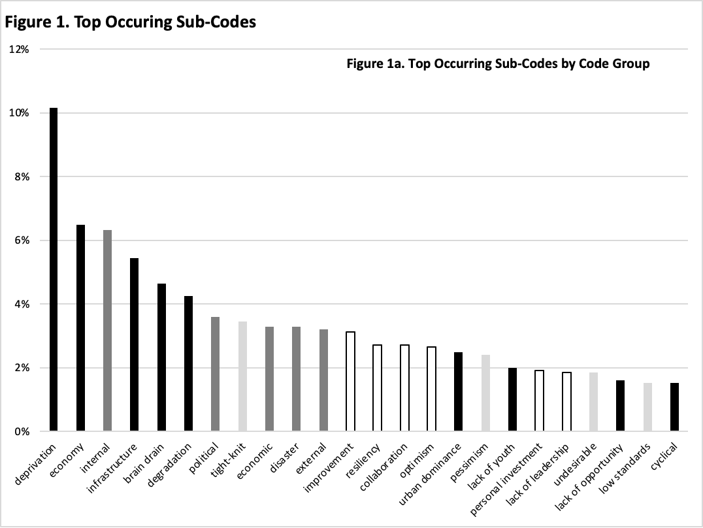
Alt text: A bar graph displays the frequencies of top occurring sub-codes. An embedded pie chart displays the top-occurring sub codes by code group.

Table 2. Co-Occurring Sub-Codes Correlations
Co-Occurring Sub-Codes | Count | Coefficient
internal-disaster | 34 | 0.40
optimism-improvement | 18 | 0.33
external-political | 20 | 0.31
improvement-collaboration | 14 | 0.24
resource deprivation-infrastructure | 38 | 0.24
low standards-apathy | 10 | 0.23
political-internal | 23 | 0.23
lack of youth-brain drain | 15 | 0.22
infrastructure-degradation | 20 | 0.20

Alt text: Table displays co-occurring sub codes with the correlations coefficients greater than 0.20, along with the frequencies of these co-occurring sub-code pairs.

Figure 2. Statistical Overlap of Codes as Internal and External Phenomena
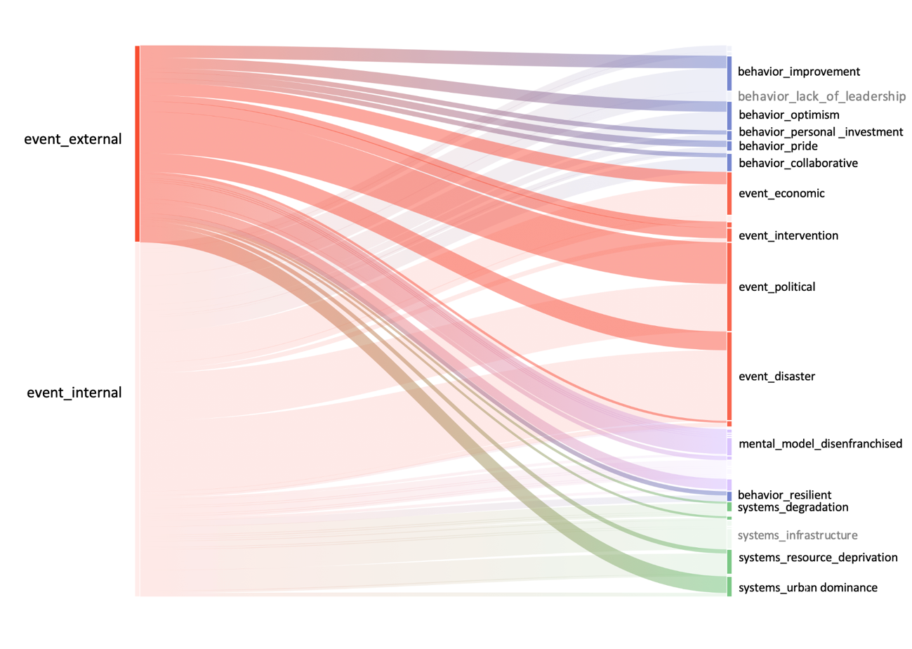
Alt text: Graphical representation of the statistical overlap of codes that identify internal and external phenomena as identified by interviewees.

